Final Report for STAD81 Causal Inference

Project: Effects of TKO/KO losses for a UFC fighter

By: Artem Petrishchev & Kobe Louis

Introduction

In the world of sports, MMA (Mixed Martial Arts) stands as one of the most physically demanding and unforgiving sports on the global stage. Fighters showcase their skills in hand-to-hand combat, demonstrating various disciplines and techniques. Within this realm lies the success and the tolls extracted from defeats, more specifically in the form of TKO (technical knockout) and KO’s (knockouts) have long intrigued analysts, medical professionals, and enthusiasts of the sport. This paper will delve into the profound effects of Technical Knockouts (TKO) and Knockouts (KO) losses on a UFC fighter's career. The primary goal is to understand the implications of these losses and identify contributing factors that make a fighter susceptible to TKO/KO outcomes. Seeking not only their immediate implications but also their enduring effects on a fighter’s trajectory.

At its core, this research aims to provide a comprehensive exploration of the profound impact of TKO/KO losses on a UFC fighter's career. Beyond the statistics, we endeavor to identify the contributing factors that render a fighter susceptible to such outcomes. TKO and KO, beyond being routine occurrences in the octagon, carry ramifications that extend far beyond the physical realm. Fighters facing these outcomes may contend with concussions, brain trauma, and other severe head injuries, potentially leading to long-term cognitive impairments and neurodegenerative diseases, such as Chronic Traumatic Encephalopathy (CTE). These TKO/KO incidents can significantly impede a fighter’s career and compromise their quality of life outside the cage as well.

Data Collected/Cleaning & Remarks

To begin, we began with a meticulous collection of data gathered from the UFC Stats main webpage, specifically homing in on fighters’ events and details. To gather this repository of comprehensive fighter statistics, we utilized a web scraper. This allowed us to procure a diverse array of fighter attributes ranging from fundamental metrics such as Significant strikes landed, takedown statistics, etc. to more general aspects such as age, height, weight, and conclusive outcomes of each bout. Focusing on the most recent 5000 UFC fights for simplicity, we gathered roughly 10,000 entries accounting for dual outcomes inherent in each contest, i.e. Win or Loss. Our data was then separated by those who suffered TKO/KO loss as our treatment variable, and the control variable would be the fighters who have never experienced a KO/TKO loss.

Considering we focused on the most recent 5000 UFC fights, it is imperative to note that amateur and other organizational fight records are worth looking into but were not considered, and due to this, we would strictly focus on a fighter's UFC record. Additionally, upon inspection, some bouts were recorded as “Catchweight”, Catchweight doesn’t necessarily apply to a specific weight class, it is introduced when a fighter is not able to make the allotted weight before their bouts and hence must fight at a slightly heavier weight than what they agreed upon. Recognizing this as a distinctive scenario requiring separate considerations due to weight class deviations, we excluded all bouts that were fought at catchweight.

This being an observational analysis, it inherently bears the risk of unmeasured confounders introducing bias. This bias introduction and the multiple unmeasured confounders affect the accuracy of our predictions. Secondly, since the number of unmeasured confounders is unknown, we can list some potential ones that could influence the likelihood of getting TKO/Koed. Impactful confounders include:

1. Training Intensity & Quality

2. Fight Camp Preparations

3. Weight Cuts

4. Mental & Emotional Status

5. Injury Status

Upon further inspection, we removed any null or missing entries within our dataset, and well as not concern ourselves with bouts that ended in an NC (no contest), or DQ (disqualification). The reasons for this are that it would be very hard to measure the impacts of either an NC or DQ and secondly it would involve further meticulous inspection of these fight outcomes. Lastly, we added a separate column in our data sheet to include the total number of fights per fighter given the date within the UFC, considering NC and DQ are excluded.

Initial Findings:

We noticed that the highest percentage of TKO/KO’s occur in the heavyweight division, roughly 50% of all fights in that weight class ended by TKO/KO. The lowest percentage of TKO/KO’s occur in both the lightest weight classes for both females and males, respectively 125lbs for Males and 115lbs for Females. There are more fights occurring at Lightweight (155lbs) than any other weight class and this could be due to numerous variables, such as the Lightweight being the most median weight and hence it is most achievable considering the average male person. Another reason as to why there are more fighters in the lightweight class is because of one man, named Connor McGregor. He is considered the “Cash Cow” in the UFC, meaning if you fight him, you will make a great financial gain regardless of the outcome. This all stems from Connor’s popularity and his movement within the MMA world.

Below is a breakdown of the UFC Fighter weight Classes for context as well as some notable features in our data set:

Strawweight (115lbs, females only) Welterweight (170lbs, males only)

Flyweight (125lbs, males and females) Middleweight (185lbs, males only)

Bantamweight (135lbs, males and females) Light Heavyweight (205lbs, males only)

Featherweight (145lbs, males only) Heavyweight (Under 265lbs, males only)

Lightweight (155lbs, males only)

SLpM - Significant Strikes Landed per Minute, Str. Acc. - Significant Striking Accuracy, SApM - Significant Strikes Absorbed per Minute, Str. Def. - Significant Strike Defense (the % of opponents strikes that did not land), TD Avg. - Average Takedowns Landed per 15 minutes#, TD Acc. - Takedown Accuracy#, TD Def. Takedown Defense (the % of opponents TD attempts that did not land), Sub. Avg. - Average Submissions Attempted per 15 minutes, Age – is recorded at the day of the bout, Height, Weight, Fighter Record, Outcome and Date of Fight

Methodologies

In our pursuit of unraveling the dynamics surrounding a KO/TKO loss, we performed linear regression (matched pairs and unmatched) as well as propensity score matching using nearest neighbors. PSM (propensity score matching) was utilized to reduce the impact of confounding variables, balance observed covariates between our treatment and control groups. Our findings for this method showcased that three variables, namely, SLpM (Significant Strikes Landed), TDAcc ( Takedown Accuracy ), and TDDef ( Takedown Defense ), were the only variables that were balanced after getting the averages of the matched pairs as well as running t-tests.

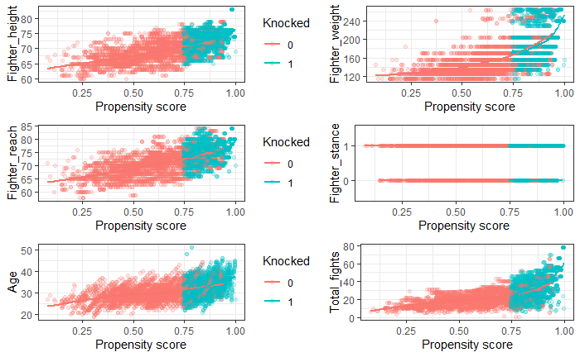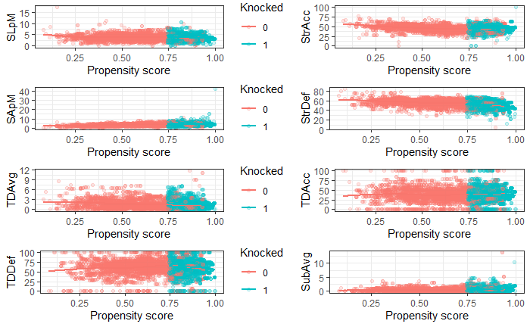

In our regression model, we observed three variables, namely, Knocked, Age, and Fighter Stance held the highest negative coefficients amongst other variables in consideration. Knocked had the highest most negative coefficient standing in at -62.9. Knocked as a variable means whether you have suffered a TKO/KO loss in your UFC career. This indicates that the biggest factor for a UFC fighter experiencing a TKO/KO loss is that he has already suffered a loss by KO/TKO. This is also backed up by the fact that after a concussion, there is greater susceptibility to sustaining another concussion and that subsequent concussions occur with less force and take longer to resolve. Second to that would be Age, at -29.9, and then followed by fighter stance at -20. Age is completely justified as the young eat the old in combat sports and this has been observed throughout history. The Orthodox stance was a bit of a surprise but made sense since most fighters fight at the orthodox stance hence it being the most popular stance, fighters are more used to the stance and can work around this stance to land a significant blow. The regression on the matched pairs showed a propensity score for those that got knocked is at least 75% for matched pairs. Propensity score for those who have not been knocked out followed a normal distribution.

Future Work

Feedback was given from our presentation:

During the class presentation, it was advised that we should split the groups a step further by separating those who got KO’d separately from those who got TKO’d. After some consideration, we figured this would be a good approach to come up with a more conclusive statement surrounding the impacts of TKO/KO losses. Another suggestion would be to measure the height-to-weight ratio. Perhaps taller fighters are harder to knock out because it’s harder to reach their head, this is something worth noting and analyzing for a more accurate representation. Another peer suggested classifying the specific area a fighter got hit and from this, we can perhaps measure how many punches at a weight class can signify an upcoming KO/TKO. This does come with some uncertainty as there is no means of measuring the fighter’s blow impact during a live fight, thus it would be very hard to notice when a fighter is throwing 100% or at a more controlled pace (70%). Of course, if you are throwing (100%) your punches are more likely to knock someone out but not everyone can consistently throw (100%) for 3 or 5 rounds.

Pros & Cons:

Pros: Cons:

* Very fun, interactive project - Lots of variables, multidimensional
* Practical application - Model limits & Generalization
* Future Research Avenues - Selection bias and Observational study limitations

Conclusion

If you want to have a successful and long career in the UFC, avoiding getting knocked/technically knocked out would be the first and foremost important aspect of longevity in the UFC. Second to that would be to stay as relatively young as you possibly can. Father time waits for no one, and this is especially the truth in the UFC. Lastly, being as lightweight as possible could significantly reduce your chances of being hit by a devastating blow as punches are weaker the lighter weight class you fight at. Any increase in either one of these variables will contribute to the chances of you suffering a KO/TKO loss. Being knocked out not only disrupts your longevity but will also reflect on your future performances significantly.

References (Images) :  
  
<https://s.yimg.com/ny/api/res/1.2/MPpo5r5bHPEkrHbpgnLIAA--/YXBwaWQ9aGlnaGxhbmRlcjt3PTY0MDtoPTQyNw--/https://media.zenfs.com/en/homerun/feed_manager_auto_publish_494/9339f60e0e8869fefc6f4bb151f5991b>

<https://www.reddit.com/r/ufc/comments/10zu4t4/josh_emmetts_weight_cut_is_brutal_wtf/>